UTRJEVANJE ZNANJA

ANGLEŠČINA, 2. RAZRED

1. **Ob poslušanju pesmi Spring is here reši nalogo. Sličico živali, ki nastopa v pesmi, prenesi v preglednico.**

|  |
| --- |
| **SPRING IS HERE** |
|  |

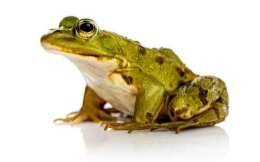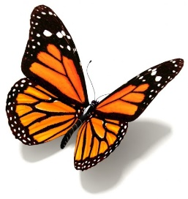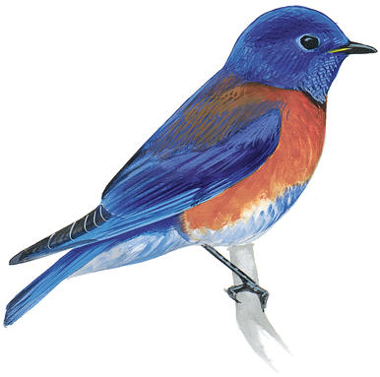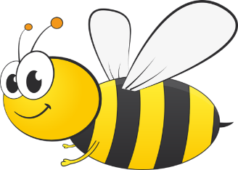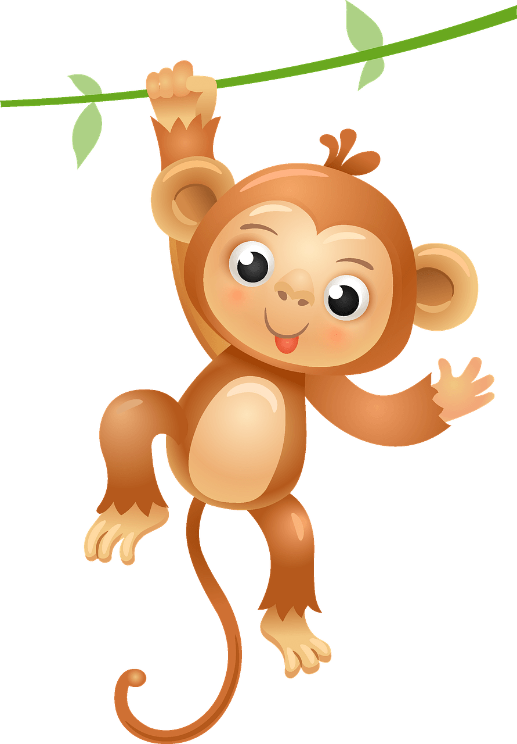****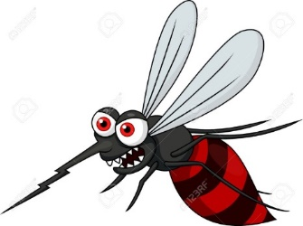

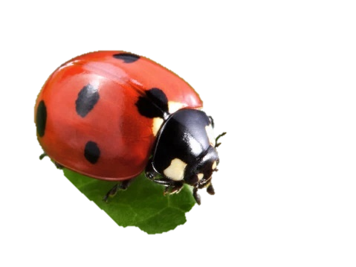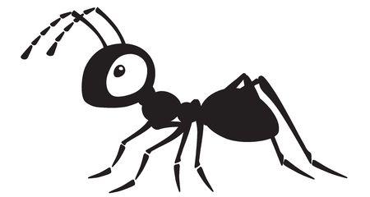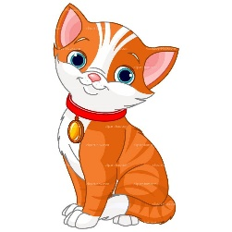

1. **Preberi in poveži. Glej primer.**

|  |  |  |  |  |
| --- | --- | --- | --- | --- |
| Rezultat iskanja slik za banana clipart |  |  |  | a potato |
| Rezultat iskanja slik za pear clipart |  |  |  | an onion |
|  |  |  |  | a banana |
| Rezultat iskanja slik za carrot clipart |  |  |  | a carrot |
| Rezultat iskanja slik za onion clipart |  |  |  | a pear |

1. **Poskušaj dopolniti povedi. Pomagaj si z besedami v okvirčku in s sličico hiše.**

|  |
| --- |
| bedroom on fridge in bathroom |



|  |
| --- |
| The toilet is in the ____________________. |
| The sofa is _____ the living room. |
| The ______________ is in the kitchen. |
| Shelf clipart kid 2 - ClipartBarnPot Plant Clipart Poinsettia Plant - Non Flowering Plants Chart ...  The flower is _____ the shelf. |
| The bed is in the ____________________ . |